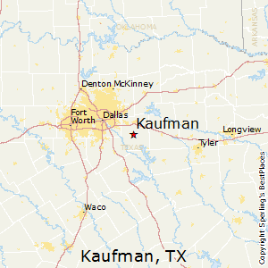

Located 30 miles southeast of Dallas and only 40 minutes from downtown, Kaufman is a community that is surrounded by incredible growth. Yet Kaufman still maintains its small-town heritage by adopting development standards that are flexible enough to meet the challenges of new urbanism and still preserve what we have that is good.

**Air Service**

**Bus Service**

**Freight Carriers**

* Nearest airport – Terrell Municipal
* Runway length – 5,006 ft.
* Runway surface – Hard
* Lighted – Yes
* Fuel – Yes
* Instrument landing system – NDB, GPS
* Airport within 1 hour – DFW International and Dallas Love Field
* Interstate carriers – 2
* Intrastate carriers – 2
* Highway bus service – Yes
* Overnight courier – Yes
* Star Transit – Curb to Curb service

**What makes Kaufman so unique is that it is one of the last four lane divided highways out of Dallas that it is not nearly built out. Kaufman is still surrounded by mini ranches, working agricultural land and rural estate living. But this community of 8,101employs over 4,000 people. Half of our residents commute into the city for their work and over half our daytime employment commutes in from the surrounding area.**

**Kaufman is a city of 8,812 with no annexation plans, that lies in a county of 162,094 residents. It is the county seat, the heartbeat of the county. State Highway 175 is the only divided highway between Interstate 45 and Interstate 20 that is the pathway from the Dallas-Fort Worth Metroplex to all of East Texas.**



* ITS EQUIPMENT LEASING & MAINTENANCE LLC
* PLUM TREE APARTMENTS LP
* JWS LAND LTD
* MICA STEELWORKS, INC
* WAL-MART REAL ESTATE BUSINESS TRUST
* MACK KAUFMAN
* TABLES MANUFACTURING INC
* KOLDER INC
* BROOKSHIRES GROCERY COMPANY
* WAL-MART STORES 01-265

Top 10 Tax Payers

* Kaufman County – 656
* Kaufman ISD – 576
* Walmart – 288
* TX Health Presbyterian – 223
* Numo Manufacturing – 182
* Advanced Tabco – 187
* TVEC – 124
* Brookshires – 102
* MICA Steelworks – 85
* Kaufman City – 78
* **TOTAL: 2501**

Doing Business in Kaufman

Taxation (Per $100 Assessed Value)

* Kaufman County - $0.3289580
* Kaufman City - $0.7600000
* TVCC - $0.1109900
* Kaufman ISD - $1.0848000

**TOTAL: $2.284748**

* Municipal Sales Tax – 1%
* State Sales Tax – 6.25%
* Econ. Dev. Sales Tax – .25%
* Streets - .25%
* Property Tax Relief - .50%

*Source: Kaufman County Tax Office

*Source: Kaufman County Tax Office

Top 10 Employers

*Source: Kaufman County Tax Office

**POPULATION BY AGE**

**POPULATION**

*Source: worldpopulationreview.com

**6.09%**

**% GROWTH RATE**

**8,812**

**POPULATION BY RACE**

**POPULATION BY INCOME**

POPULATION BY RACE

**MEDIAN HOUSEHOLD INCOME**

**$52,019**

**MEDIAN AGE**

**MEDIAN HOUSEHOLD SIZE**

*Source: worldpopulationreview.com

*Source: worldpopulationreview.com

**HOUSEHOLDS**



*Source: point2homes.com

**2,229?**

*Source: worldpopulationreview.com

**3.65**

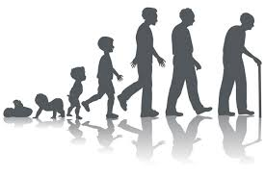

*Source: worldpopulationreview.com

**30.9**

*Source: worldpopulationreview.com

*Source: datausa.io/profile/geo/Kaufman-tx

*Source: worldpopulationreview.com

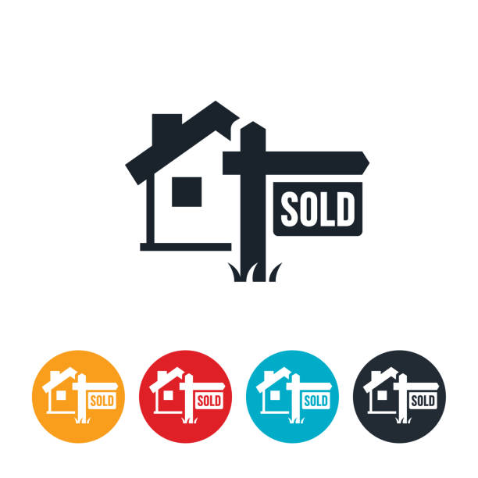

**AVERAGE MONTHLY RENT**

**\*AVG. 768 SQFT 1 BDRM**

**$267,571**

**AVERAGE HOME VALUE**

**ENROLLMENT**

**TOTAL**

* Helen Edwards – 464

(Pre-k & Kindergarten)

* Monday Elementary – 489

(Grades 1-5)

* Phillips Elementary – 493
* (Grades 1-5)
* Nash Elementary – 632
* (Grades 1-5)
* Kaufman Junior High – 930

(Grades 6-8)

* Kaufman High School – 1306

(Grades 9-12)

* Gary Campbell High School – 60

(School of choice: early graduation)

**\*Kaufman High School is A+ rated**

Kaufman ISD

Total

**TOTAL EMPLOYMENT RATE WITHIN KAUFMAN – 67.9%**

**UNEMPLOYMENT RATE KAUFMAN COUNTY – 3.8%**

* # On Council – 7
* # Municipal Police – 20
* # Paid Firemen – 9
* # Volunteers – 21
* City Zoning Body – Yes
* Master Plan - Yes

**CITY GOVERNMENT**

Enrollment

Pre-K – 12th Grade - 133

*Source: Kaufman Christian School

**4,313**

*Source: Kaufman ISD

**NEW SINGLE FAMILY RESIDENTIAL PERMITS 2023**

**AVERAGE YEAR BUILT**

*Source: zillow.com

*Source: City of Kaufman

**54**

*Source: point2homes.com

**1976**

*Source: zillow.com

**$1,895**

*Source: worldpopulationreview.com

*Source: City of Kaufman

**COMMUNITY AMENTITIES**



* Total hospital beds – 91
* Nursing Homes – 2
* Churches – 25 (1 Catholic, 24 Christian)
* Parks – 3
* Basketball Courts – 2
* Tennis Courts – 2
* Sports Complex (baseball fields) – 1
* Motels – 2



**Property Taxes**

*Source: Kaufman County Tax Office

**\*total assessed value**